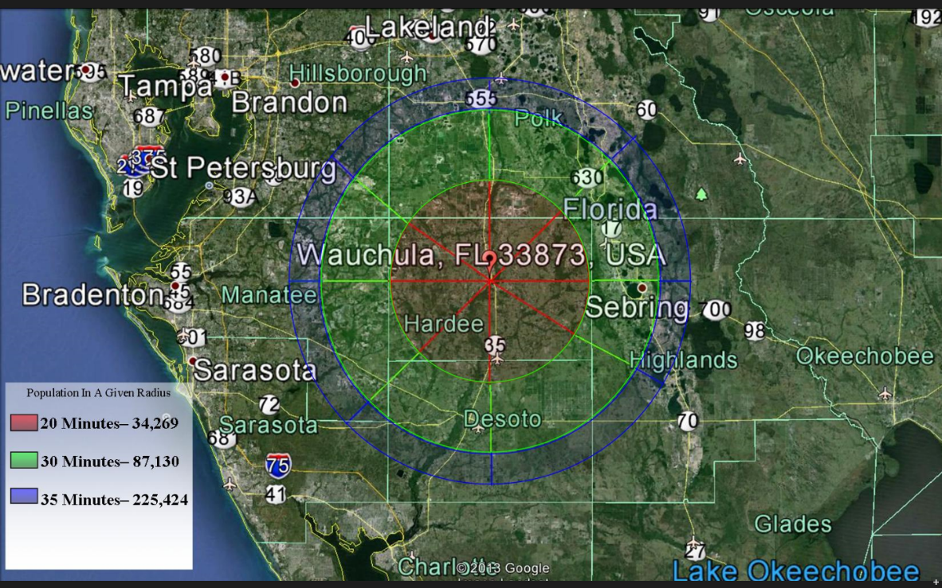

* SALE PRICE $690,000
* ACREAGE 2.766 acres
* ZONING Vacant Commercial
* NOTES Undeveloped lot
* AADT 9,100 (Average Annual Daily Traffic – FDOT 2012)
* CONTACT Gary DeLatorre (863) 832-0508

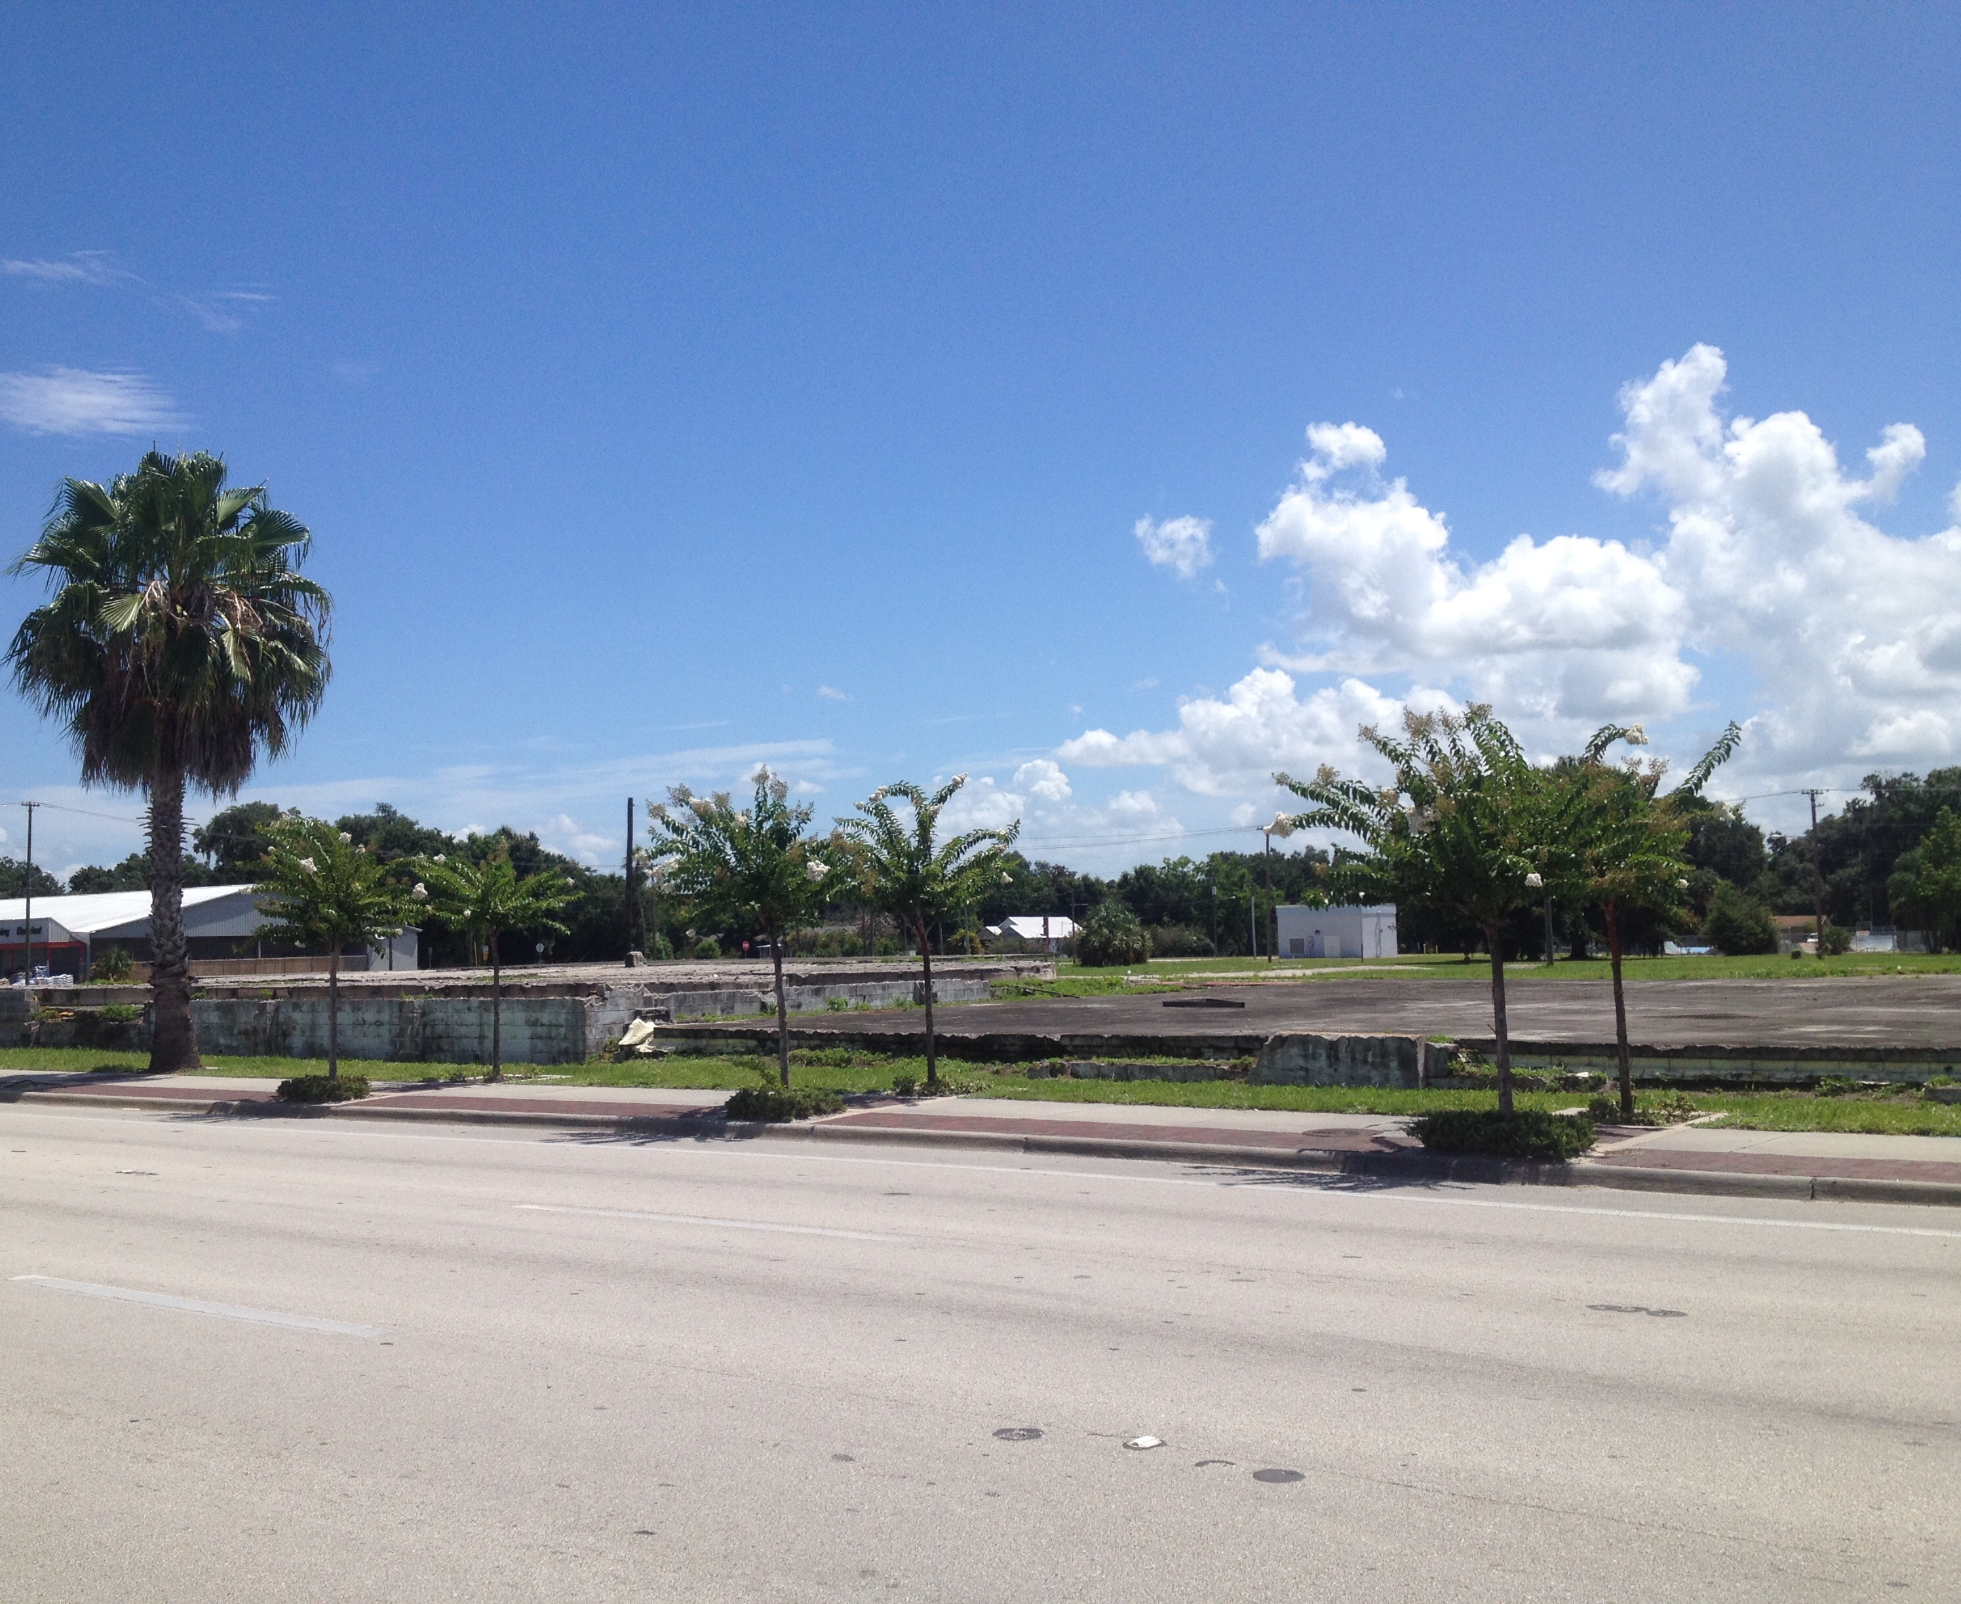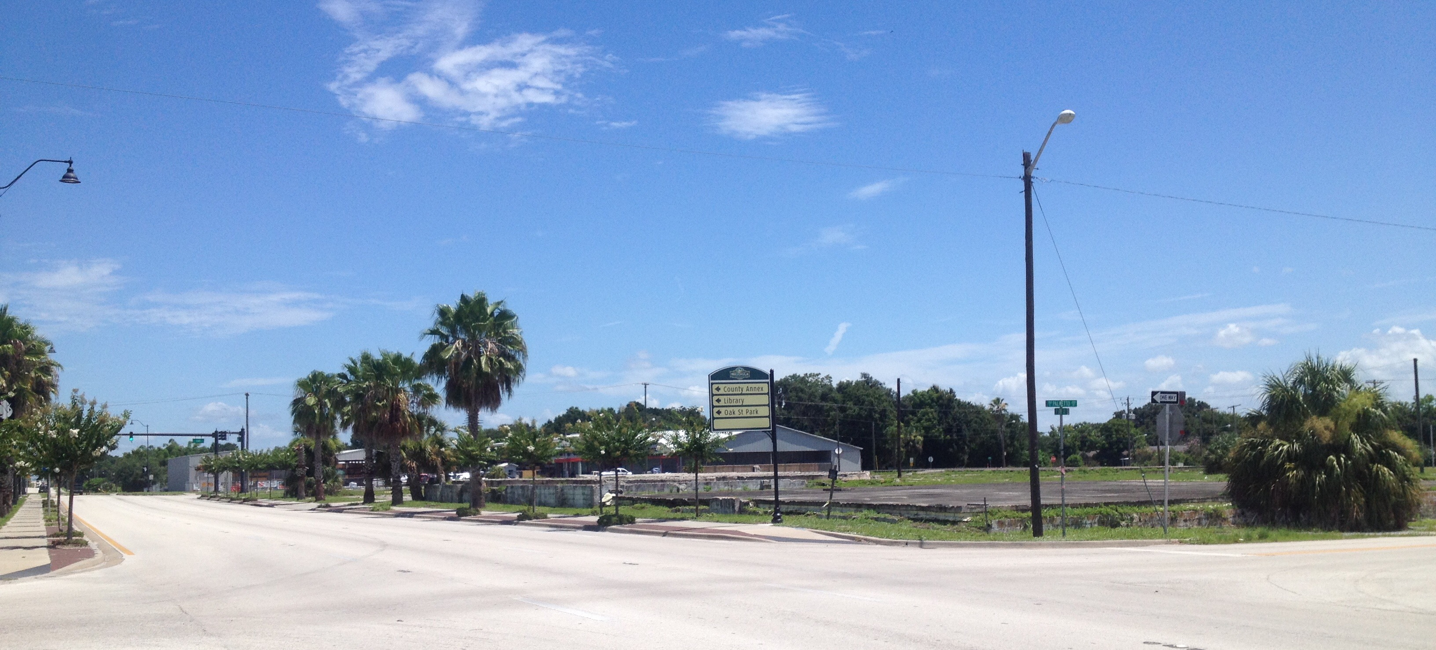

The City of Wauchula serves as the county seat for Hardee County, located in south central Florida. The general population of the county served by the commercial hubs of Bowling Green, Wauchula, and Zolfo Springs is approximately 28,000 citizens. There are 9,500 households and approximately 1,300 commercial business entities located in this 637 square mile area.

220 5th Ave N, Wauchula, FL 33873

Community Redevelopment Agency: (863) 767-0330; jnewman@cityofwauchula.com