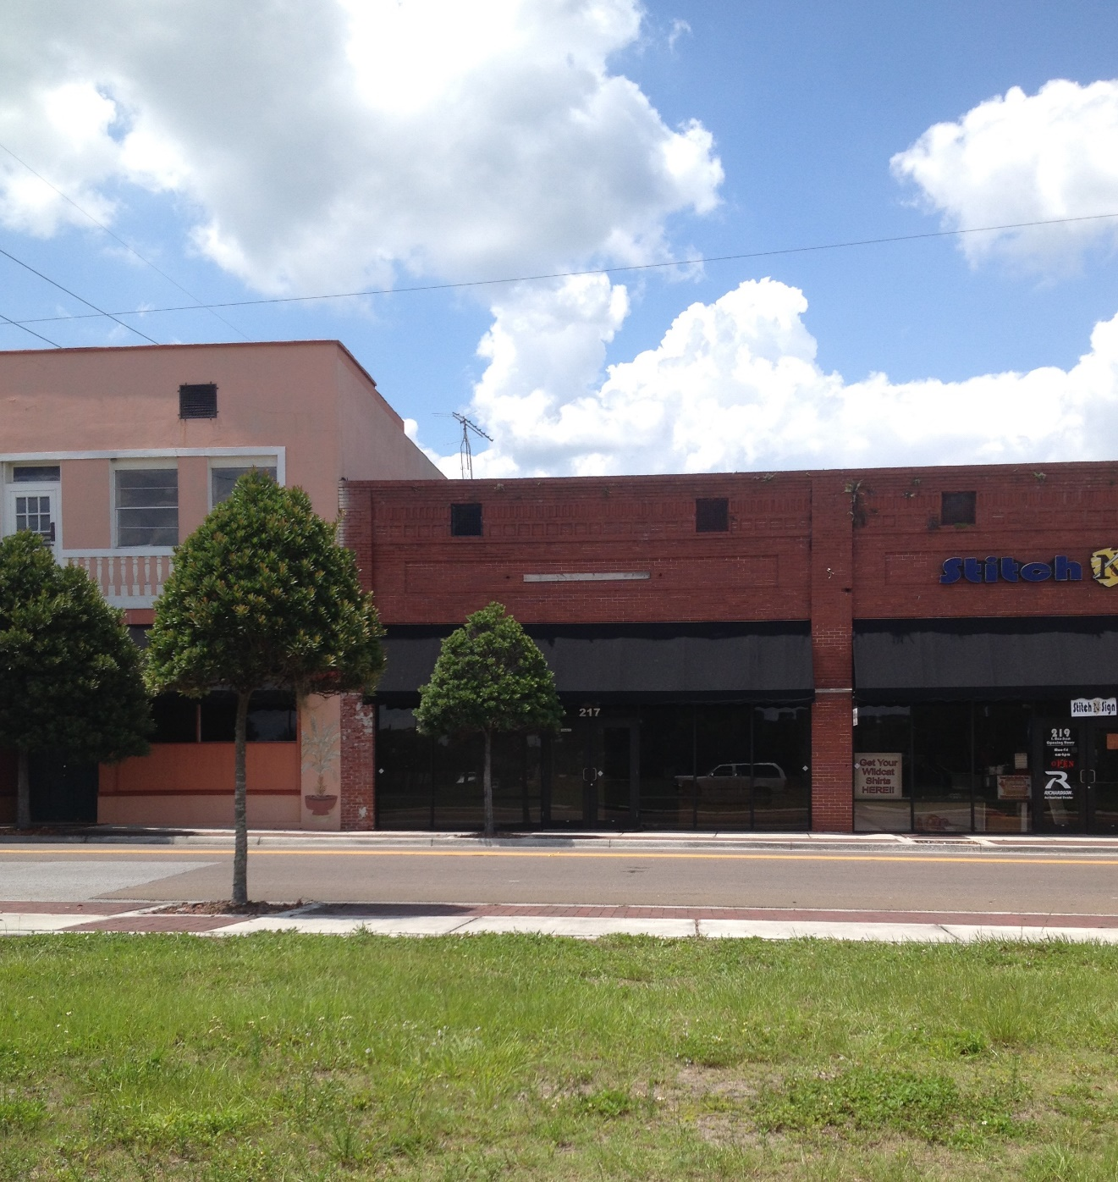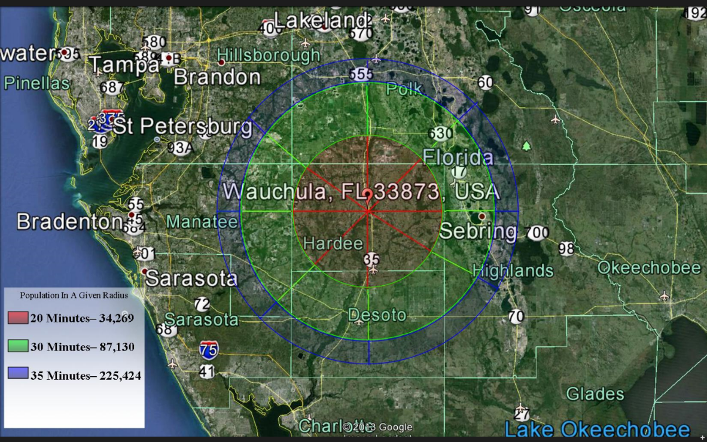

* LEASE PRICE
* PURCHASE PRICE
* BUILDING 8,550
* YEAR BUILT 1924
* ZONING HC-1 Historic Commercial
* AADT 9,100 (Average Annual Daily Traffic – FDOT 2012)
* CONTACT

The City of Wauchula serves as the county seat for Hardee County, located in south central Florida. The general population of the county served by the commercial hubs of Bowling Green, Wauchula, and Zolfo Springs is approximately 28,000 citizens. There are 9,500 households and approximately 1,300 commercial business entities located in this 637 square mile area.

217 E Main Street, Wauchula, FL 33873

Community Redevelopment Agency: (863) 767-0330; jnewman@cityofwauchula.com