**130 West Main Street**

**Wauchula, Florida 33873**

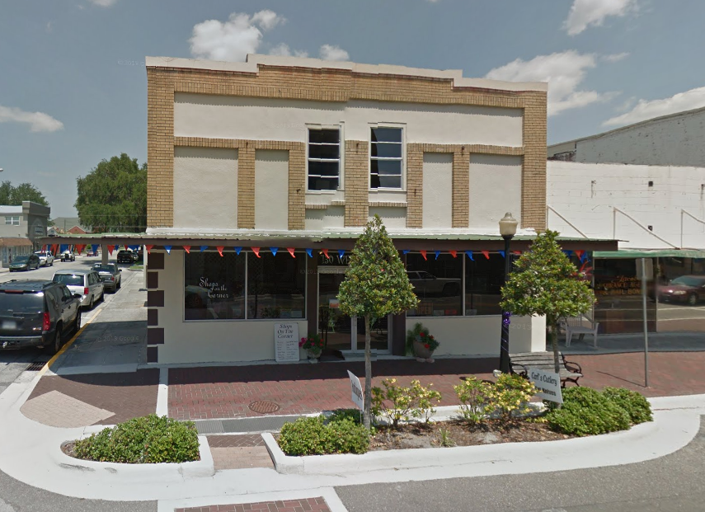

* PURCHASE PRICE $205,000
* BUILDING 7,000 sq ft
* YEAR BUILT Completely renovated in 2005
* ZONING HC-1 Historic Commercial
* AADT 9,100 (Average Annual Daily Traffic – FDOT 2012)
  + - * NOTES Second floor unfinished. Plumbing upstairs. Two handicap accessible bathrooms downstairs.
* CONTACT Trisha Rouse (863) 781-7880

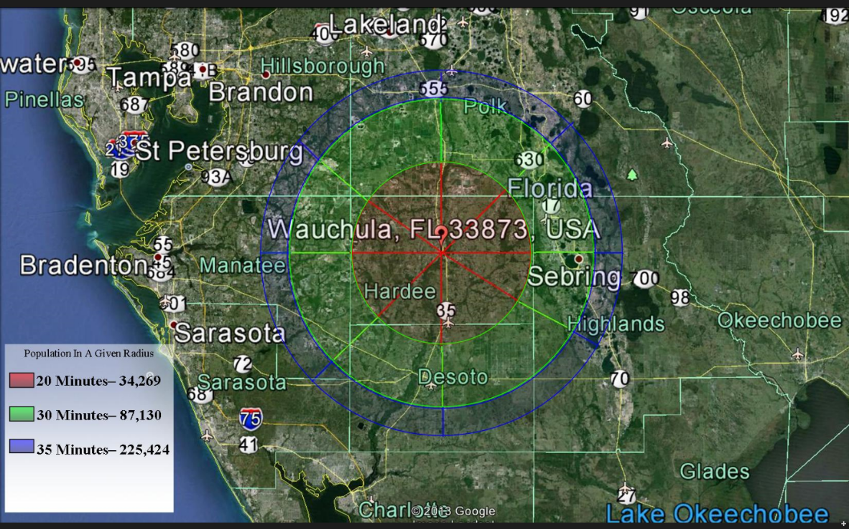

Community Redevelopment Agency: (863) 767-0330; jnewman@cityofwauchula.com

The City of Wauchula serves as the county seat for Hardee County, located in south central Florida. The general population of the county served by the commercial hubs of Bowling Green, Wauchula, and Zolfo Springs is approximately 28,000 citizens. There are 9,500 households and approximately 1,300 commercial business entities located in this 637 square mile area.